Filips Pohils

Dissertation Documentation

### 

Filips Pohils 1

Dissertation Documentation 1

BSc Software Engineering 1

Background 2

Project rationale 2

Academic Journals 3

Relevance 4

Aims and objectives 4

Methodology 5

Summary of existing business limitations requiring resolution 7

Functional requirements 8

Performance requirements 8

Draft interface design 12

System implementation 18

Textual Analysis 18

Functionality 18

Attribute listings 20

Requirements Engineering 24

Event Charts 24

Progress 29

Further investigating 29

6. Test Strategy 30

Evaluation 34

5.3 final system interface displays 35

**Online Doctor Appointment Booking System PHP and Mysql - https://www.youtube.com/watch?v=KqpKRv9m-PU** **43**

**Doctor Appointment Booking System in PHPhttps://www.youtube.com/watch?v=mOsG6ehkMQc** **43**

**best clinic appointments management system in php part 1** **43**

**How To Build a Simple Appointment Booking App (Mongo, Express, Angular, Material)** **43**

### 

Dissertation proposal Basic Appointment System

Introduction

## Background

Annas Ladies’ is a Northamptonshire based walk in hairdressing salon that is looking to expand and improve their business systems. This business is currently looking to add an appointment system which will allow people to come in by requested date and time. The current problem they are facing right now is that using a paper-based system is not efficient and will cause distraction to workers on walk-in days. This problem stuck out to the developer as modern businesses rely on productivity and ease of use for the customers. One of the best ways to improve those crucial parts is to implement computerised systems within the business. Creating a website that shows available times, has staff area, shows events etc. would help significantly.

## Project rationale

For this project I will start with the main idea of the problem domain and aim to achieve it with the system. These are subject to change as more meetings with the business owner will be made expanding on each problem in more detail.

|  |  |
| --- | --- |
| Basic problems | *Proposed solution* |
| *Creating paper appointments is time consuming and unreliable* | Computerize the appointment system creating a website and adding all the needed functionality to easily create/edit/delete appointments. |
| *Changes in times are only available through calling the shop or visiting it* | To avoid confusion with new times or special offers or any new information about the salon users will be navigated to the website where they will be able to find all the needed information without distracting the shop. |
| *Papers can get lost or damaged causing trouble to the business* | Keeping sure that website is safe and secure for staff and regular users. Ensuring all data will be backed up and accessible in case of emergency. |
| *Additional functionality* | ***Proposed solution*** |
| *Staff area* | Additionally, a staff area can be created to show holidays, sick days or any relevant information about staff and customers. This area will have a login and password for protection. For business to grow you would like to know |
| *Paper based performance reports* | performance of the business every month, year, even daily. A website can collect all the information about appointments and show that in any area on the website. |

## Academic Journals

To make sure the problem domain is understood and will be solved appropriately, a list of academic journals has been chosen as additional research on the topic and shown below. Even though they are not directly about the topic that I chose, I still think they helped in researching the problem factors and ways to deal with them.

**Journals**

**1. Web-Based Medical Appointment Systems: A Systematic Review**

**Authors:** ©Peng Zhao, Illhoi Yoo, Jaie Lavoie, Beau James Lavoie, Eduardo Simoes, 26.04.2017.

**Abstract** The purpose of the study was to identify the benefits and barriers to implement Web-based medical scheduling discussed in the literature as well as the unmet needs under the current healthcare environment. A total of 36 articles discussing 21 Web-based appointment systems were selected for the review. Most of the practices have positive changes in some metrics after adopting Web-based scheduling, such as reduced no-show rate, decreased staff labor, decreased waiting time, and improved satisfaction, and so on. Cost, flexibility, safety, and integrity are major reasons discouraging providers from switching to Web-based scheduling. Patients' reluctance to adopt Web-based appointment scheduling is mainly influenced by their past experiences using computers and the Internet as well as their communication preferences.

**2. Business and Information Systems engineering**

**Authors:** Christof Weinhardt, Martin Bichler 27/09/2017

**Aims & Scope of the Journal**

The journal is receptive to research results from the field of business and information systems engineering as well as cutting-edge business practice findings. Specific solutions for application systems are published only if they serve as a model for other fields of application. The journal also covers important peripheral areas if developments in the narrower sphere of business and information systems engineering are substantially affected. Examples are the impact of computer science on business, individuals, and society as well as issues regarding training and further education. The journal publishes original research papers. All papers undergo a thorough double-blind review process.

## Relevance

These papers have helped the developer to create a guideline to follow when considering a web-based application website. It showed a comparable system that I can refer to when creating the developers own, showing advantages and disadvantages and importance of security within the system. These journals have outlined the demographic of working for a specific market and what key features to follow and identify them. Business and Information Systems engineeringjournal also outlines the effects of computer science on current business which helped the developer when talking to the client about the proposed solution and its effects to customers and staff.

## Aims and objectives

This project aims to create a computerised system for appointments that will be used by hairdressing salons that also can be reused and applied for diverse purposes. Fundamental aims of the project are to eliminate the use of papers and phone calls to gather information and create appointments for the customer and shift that to a web-based application system. To understand and effectively approach the project aims and objectives for the project are listed below

**Aim Purpose**

|  |  |
| --- | --- |
| Aims | Purpose |
| Look at pre-existing solutions | * Identify strength and weaknesses of already existing similar business solutions |
| Analyse current business setting | * Talk to the client and employees about pros and cons of current setting * Analyse how to integrate a computerised system evenly |
| Assemble business needs | * Formulate a full description of the problem and talk to the client. * Make sure proposed solution meets all the needed functionality * Keep improving the functionality with the development and keep talking to client |
| Create a prototype using wireframes or draft design | * If any changes needed to improve the wireframe and ensure client is satisfied with the proposed solution * Show the client created draft design |
| Develop the website | * Build the new system using appropriate programming language to the task |
| Suggest specific features based on comparable systems | * Suggest advanced features based on comparable systems |
| Test the system | * Use white and black box testing to ensure * the website works as intended * Ask workers to test it to gain another perspective on the testing * Fix any problems that were found while testing |

## Methodology

**Elicitation**

To make sure the project will be successful, different elicitation techniques will be used to achieve satisfaction for the customer on different stages of the process. For example, before the development starts it will be good to use prototypes and look for new ideas with the client at first, but later asking staff to trial and use questionnaires on the system to see how fast it is to use.

The developer will use different techniques depending on how the client works with them and feels about it. For example by showing staff the1st prototype of the website which could be in via wire-frames or simple images, that would add a lot to the overall vision of the project and what it is trying to achieve.

* **Prototyping**

By creating prototypes of the website, the developer can ask the client how he feels about the project and if it’s going in the right or wrong direction. It allows the developer to make quick changes to the prototype until the client is satisfied with the outcome. This will save a lot of time and avoid confusion with the client compared to if the developer would make the website based only on the information and show it to the client after.

Interim progress on the prototypes allowed the developer to show the client what has been done and see how the client feels with the overall direction with the website. It also helped the developer to show and make the client understand the thought process of making plans for the website and the structure of how it will be built for purpose.

* **Trials**

After the system is completed or, the website design stage takes place, asking staff to trial the developers system can be beneficial to the project. By collecting data about performance and ease of use the developer can further make changes to the system to allow more user-friendly design or add any additional features. This also helps the developer to see a third perspective view on the website.

* **Comparable systems**

To get a grasp of what the client is looking for with the project, different comparable systems will be presented. This will help the developer to understand the client aims with design and functionality of the system overall. It can also help underline the advantages and disadvantages of currently existing businesses and try to avoid them when creating this system.

When deciding on how would the view of customer be booked, we stumbled upon a website that has a great timetable view of the bookings https://www.shedul.com/

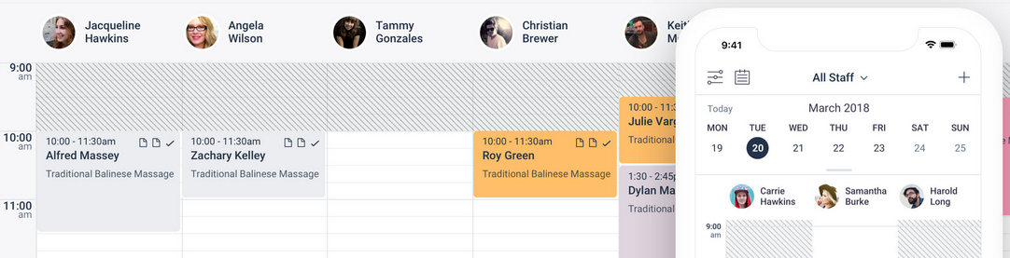

This will be used as inspiration for our website, as similar styles will be added but also changes based on certain functions and needs for the salon will be done. As one of the main points of the website is speed and clarity of the view this could be a great future implementation for the website.

Analysis & Specification

When all the information is gathered, analysis of the information will be important to get a better understanding of the overall problem. Analyzing the problem before specification is started to not make mistakes writing the specification itself. Specification will start when a good understanding of the project is achieved. Specification will include all the body functionality required defined by the client during elicitation stage

**Problem domain description**

The current business is operating on only walk in, paper-based systems. To allow the business to expand and grow they are looking forward to implementing a website using a booking system to allow new customers to book her appointments in advance on certain days. By using this method, the business will expand and fill the empty gaps with no clients and fill in more days in the weeks with work. To store information about services, databases will be used that will store times and dates of each customer and each service. This data will be crucial for the business and it has to be accurate. The website itself will be fairly basic but will have functionality that will allow any customer to register and book the appointment without needing to call in or contact a member of staff in any way.

**Existing business operations**

Existing business operations are using only paper-based systems, and only allows customers to walk in during the working hours. Opening hours are usually from 10 until 6, and when the customer comes in they agree on the service and the customer pays either cash or card.

### Summary of existing business limitations requiring resolution

* **Customers don't have a way to book an appointment remotely**

Since customers can’t easily book appointments remotely, this is a missed opportunity for the business to gain profits. A lot of customers would like to be certain that when they come to the salon they don’t have to wait, and appointments can really help achieve that.

* **In order to book an appointment customer would have to call in and ask a member of staff to book an appointment for them**

This is a drawback for the business as it distracts the staff from work to answer and book appointments for clients. This is not a healthy business operation and can be certainly improved with a software solution

* **Paper-based stock records system**

Paper based systems are a dangerous security issue for the business. Having only paper based backups for documents is unsafe for documents as if they are destroyed by fire hazard or damaged by water they will be lost forever.

* **No way to communicate business information/events to customers besides them coming in or calling in**

Having no effective way to communicate events or business policy changes is not helpful to the customers. By implementing software solutions the business will communicate to its customers in a more effective way.

This is a list of tasks that will have to be investigated and resolved for the business.

### Functional requirements

A fully working business orientated website with NoSQL database connection and records management system will be created to resolve those problems.

* **Front-end design and functionality of the website**

A user friendly front end user interface that will navigate people through the website and its services. It will present welcoming and informative information for existing customers and new potential customers.

* **Back-end security and database connection to the records management system the staff can access**

For this website the developer has chosen to use NoSQL relational databases. This was chosen because the business is comparatively small and will not require complex queries to find relevant information. The developer will also secure the back end of the website using different techniques to protect the information of users such as name, password and email addresses.

* **Database system that includes all the requirements for the services**

A back end database system will store all the important information on the website. As talked with the client, it will only store information about customer booking, but further expansion of the database systems can help the store by storing information such as stocks of inventory and more.

* **Layers of protection and ways to avoid stealing of data or accounts**

Secure ways of encrypting passwords and user information will be held to help protect that information.

### Performance requirements

**Speed/Capacity**

Even though the speed of the website doesn't play a crucial role. Personally when using a website that is very slow, the first reaction is to close it. And I don't think I'm alone in this. The capacity of the website should be so that it always can make new records no matter what. Thankfully, storing records doesn't require much space at all since it's only text data, so that should not be a problem overall.

**Reliability**  
The website will be constantly running and will give customers the ability to book an appointment whenever the business has working hours. The website will provide secure ways of storing passwords and personal information of customers. Staff won't be able to see passwords of the customers, and data about some of the information will be stored safely.

**Usability**

The website will require an Internet connection so that the user can use the website. To use the website, the user will also need to have a way to access the website. The graphical user interface will also be available to use both on phones and tablets, as that is a common way a customer could use the website. This provides multiple ways for the customer to use the website on any platform.

**Security**

Since the website will contain critical personal data such as passwords, different security techniques will be used to protect personal data of customers on the website. For example, all the passwords will be hashed and encrypted in the database. This will help protect against hackers that gain access to the database. If that happens they won’t be able to take any passwords

**Design**

Once the proposed specification details were approved by the client, draft design in a way of prototype or wireframes will be shown to the client. Any observation or criticism will affect the final design of the system. The current build of the website looks very minimalistic and simple. This was down so that every user can easily access the website and not be confused by it. Further improvements will be made when more functionality will be added to the website. Additionally improvements like sliding images on the main page or dynamic photos of services can be added to the website. All interaction with the website and give users more freedom and ease of use on the website. A good website will feel personal and fast and will give users motivation to come back for business services.

Home, appointments (services) and contact us wireframes (do not include length of website, for more information can be scrolled down)

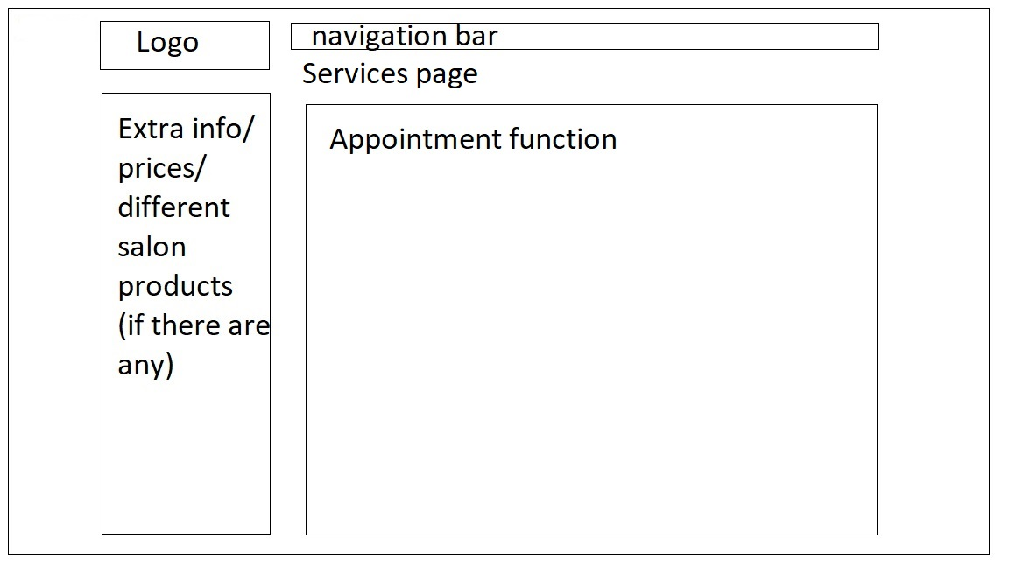

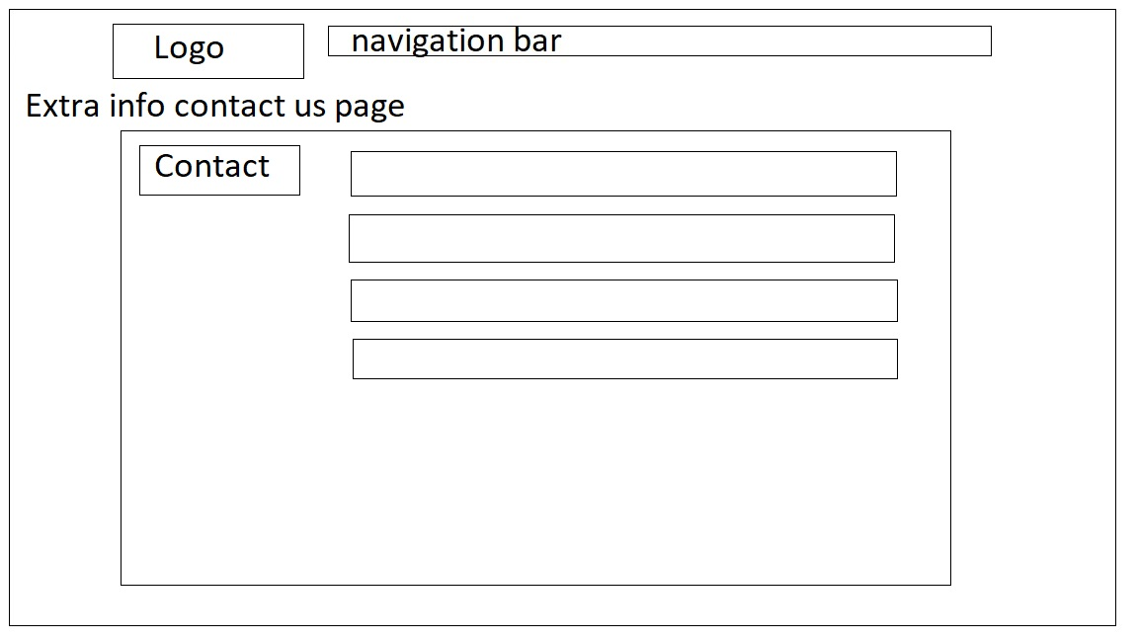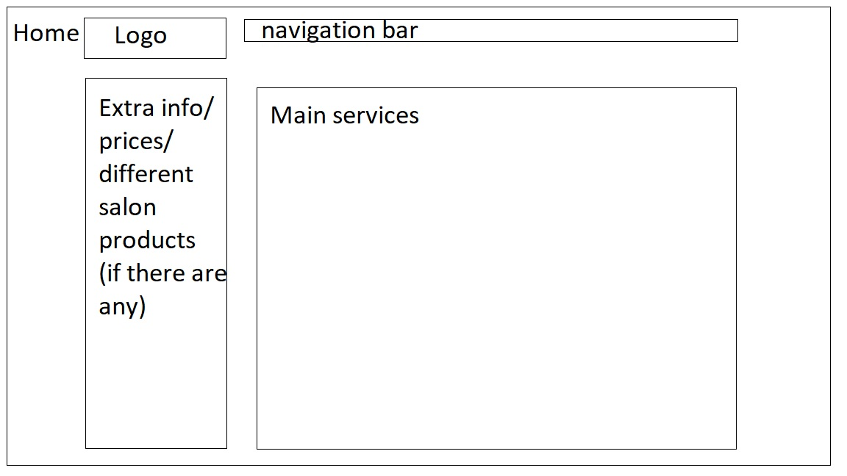

## Draft interface design

**System Navigation Diagram**

The website that will be developed for the website will be fairly simple and easy to navigate through. As the range of users will most likely vary from people who are more and less used to using online services, three-click-rule will be applied in between different pages to make sure the user is always on track and knows how to access each corner of the website.

**Guest**

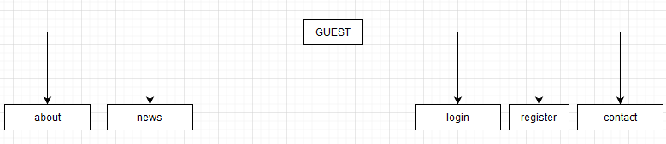

Guests will have the most basic navigation through the website, showing all the relevant info about the salon. Guests will not have the ability to book the appointments as they need to be a registered user on the website.

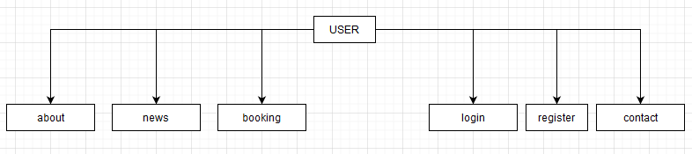

User website navigation will contain all the same links as regular guests do, but also allow the user to book an appointment at the salon using the “Booking” tab. When booking is opened they will see a list of available days and times they can book.

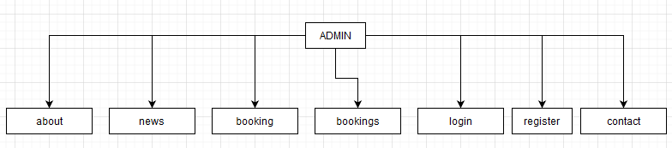

Admin website navigation allows access throughout all of the website. They can create, edit and delete bookings as well as create new users and admins.

**System Activity event diagrams**

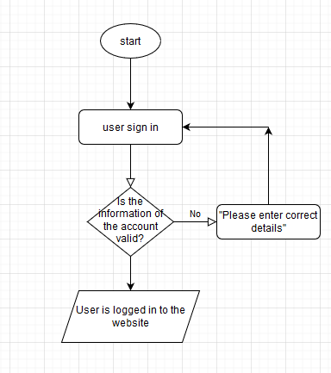

*(fig.1) “User sign in”*

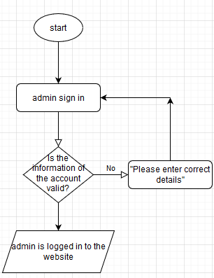

*(fig.2) “Admin sign in”*

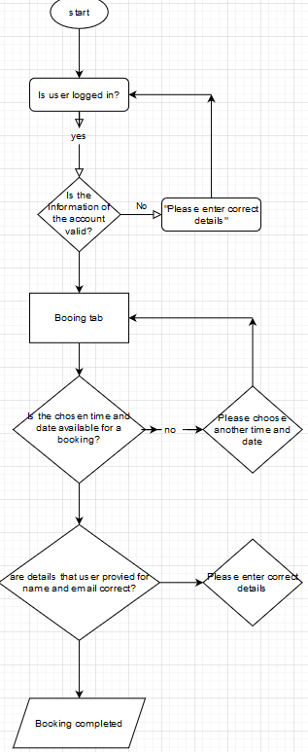

*(fig.4) “Booking an appointment”*

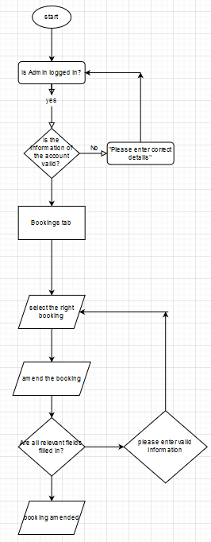

*(fig.5) “Amending the booking as an admin”*

**Design Revisions as a result of Wireframes interview**

The client was happy with presented wireframes and no major changes were needed.

**ERD design**

Entity relationship diagram was designed to cover all the basic needs of the salon. This is only for early stages of development, to create the right database tables right now and fill in the correct data. Further building the website the developer will add more tables based on needs and additional requirements if any will be needed.

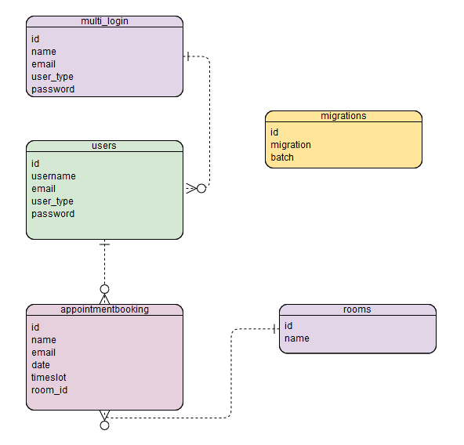

### 

### System implementation

To make sure the system is available to as many people as possible, a web-based solution is chosen for the application. For this project main languages used will be PHP, HTML, CSS and JavaScript. SQL will also be used to deal with information and back-end databases for the website.

After more investigation has been done and different frameworks will be applied to the website users will be using the developers PHP admin and SQL as they are the best Solutions and the most widely used in programming right now. That is because SQL is the most reliable and widely learnt database structure and will be available for any new coming programmer that will be working on the website in the future. As they are really widely used, that means the client will not have a problem finding other programmers to maintain the website after.

Core features will be implemented using PHP. Currently work in progress being made for the back-end of the website, connecting the database and creating an environment where data can be transferred efficiently and consistently. Different solutions and software helping on the way, for example using Laravel it was easy and clear on how to set up routes and controllers. Using commands also helped the developer save time creating routes as all of them are created in a bulk when using the terminal.

After a satisfactory level of back-end functionality is achieved the developer will use simple code to fill out the website and also will be using simple bootstrap code to help the developer along the way. The developer is using bootstrap because a lot of the code that the developer knows has been done already and is free on the internet, which will help the developer during this project. For example, a simple navigation bar that the developer will make will take the developer more time designing it than taking something simple and ready made off bootstrap. Talking with the client he agreed it would be a good way to meet all the website basic requirements and is not against anything that will speed up the process. When applying bootstrap, the developer will also edit it to fit the style of the website making sure all the features are present. Using frameworks like bootstrap will also help facing any problems containing the code as people around the internet are probably facing similar problems and are helping out each other using websites like Stackoverflow.com

## Textual Analysis

### Functionality

The core functionality of the website revolves around booking appointments for the salon. This was the initial idea for the website which will provide those services. As discussed with the client, customers will have access to a website where they can register and login to create a new booking. These bookings will be stored in the database and an admin user will be able to view all the bookings on the website in a table. For the website, it made sense to create a register system and keep track of users and admin users to easier maintain the website and have less troubles with records. If the developer would have decided to not create a login system this could allow the website users to create too many bookings or create unnecessary bookings. By having a system which users will have to be logged in in order to create bookings, you can eliminate that problem as it will not track which user is creating the bookings.

This website also is a helping hand to employees of the salon as they can now comfortably look through all of their upcoming bookings in one place. Instead of having a paper based records system, employees will easily look at all past/upcoming bookings incoming with details of the user, having the ability to contact, edit or delete the booking. This gives the staff more freedom and less time taking to create adjustments for a booking.

During the initial programming stages the developer and the client were talking more about ease of use of the website and speed. you were important for the developer and the client to make sure you get the best experience out of the website. by applying different techniques like, three click rule and having soft colours wanting to give the website a minimalistic but professional look.

When creating the database more details were needed from the client about what kinds of data will be inserted and taken away. the first impression was that only certain services will need a lot of attributes and tables but turns out there are different problems that you face when creating a small table. After searching for more database information online, I found that it is really useful to have more testing tables. They help to organise and keep references for future and also see the improvements you made to the website. I also forgot to mention failed services or any external offers tables.

*Further process*

By further investigating working on the project the developer has learned about different website wireframes and how to apply it to the website. Further meetings with the client we came to the conclusion that we need a basic construction of the website that we can then build on. With progress being done we have created a back end background of the website that can support all the aims and objectives providing. Another issue now is to make sure it's safe and secure and also will be easy to maintain for another programmer. there concerns for staff so that it will be easy to use and understandable for everybody.

**Significant event analysis**

The most important events on the website will consist of users booking an appointment. This will require the guest to create an account using a login system, and book the right date and time required.

|  |  |  |
| --- | --- | --- |
| **Event** | **Performers** | **Attributes** |
| Log in | User  New account  Staff member | id  username  email  user_type  password |
| Log out | User  Staff member | id  username  email  user_type  password |
| Book an appointment slot | New users  Customers | id  name  email  date  timeslot  room_id  book  id  name  email  date  timeslot |
| Create, read, update and delete appointment bookings | Staff  Admins | id -  name  email  date  timeslot  room_id |

**E-R model**

### Attribute listings

**appointmentbooking**

* id - PK
* name
* email
* date
* timeslot
* room_id - FK
* book
* id
* name
* email
* date
* timeslot

**bookings**

* id - PK
* name
* email
* date
* timeslot
* room_id - FK

**rooms**

* id - PK
* name

**members**

* memberID - PK
* username
* password
* email
* active
* resetToken
* resetComplete
* migrations
* id
* migration
* batch

**multi_login**

* id
* name
* email
* user_type
* password
* password_resets
* email
* token
* created_at

**posts**

* id
* title
* body
* created_at
* updated_at
* user_id
* cover_image
* users
* id
* username
* email
* user_type
* password

**Commands Queries Constraints**

|  |  |  |  |
| --- | --- | --- | --- |
| CLASS | ***CLASS NAME*** | | Part: 1/1 |
| TYPE OF OBJECT  **Brief Description of Class** | |  | |
| Queries | login user | | |
| Commands | edit, delete, create, read | | |
| Constraints | multiple people can use it at the same time | | |

|  |  |  |  |
| --- | --- | --- | --- |
| CLASS | ***CLASS NAME*** | | Part: 1/1 |
| TYPE OF OBJECT  **Brief Description of Class** | |  | |
| Queries | register a user | | |
| Commands | edit, delete, create, read | | |
| Constraints | multiple people can use it at the same time | | |

|  |  |  |  |
| --- | --- | --- | --- |
| CLASS | ***CLASS NAME*** | | Part: 1/1 |
| TYPE OF OBJECT  **Brief Description of Class** | |  | |
| Queries | bookings | | |
| Commands | edit, delete, create, read | | |
| Constraints | only admin users can user bookings crud | | |

|  |  |  |  |
| --- | --- | --- | --- |
| CLASS | ***CLASS NAME*** | | Part: 1/1 |
| TYPE OF OBJECT  **Brief Description of Class** | |  | |
| Queries | book | | |
| Commands | create | | |
| Constraints | user has to be logged in to use it | | |

|  |  |  |  |
| --- | --- | --- | --- |
| CLASS | ***CLASS NAME*** | | Part: 1/1 |
| TYPE OF OBJECT  **Brief Description of Class** | |  | |
| Queries | create a user | | |
| Commands | create, read, update,delete | | |
| Constraints | only admin users can create new admin and regular users | | |

## Requirements Engineering

### Event Charts

In this section the developer will go over relevant charts and the flow of information on the website. Creating a booking will be a simple process that requires a user to register an account and book an available slot during the day. If the slot is taken, there will be other options.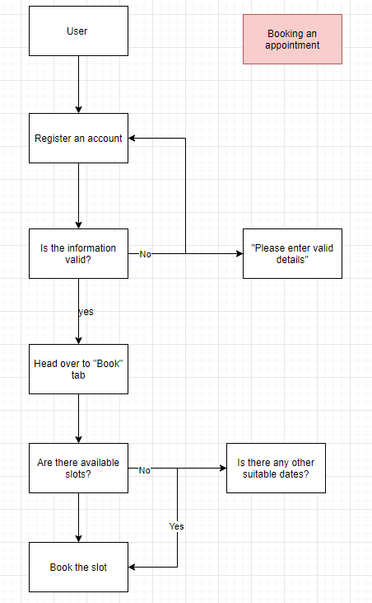

As of now, users will not be required to make a payment straight away on the website. This is done because of a client request not to add a payment system in the early stages of the trialing. As the prices would vary a lot, it would be best if a customer visits the salon on the requested appointment time and pays there for the services.

*(fig.6)*

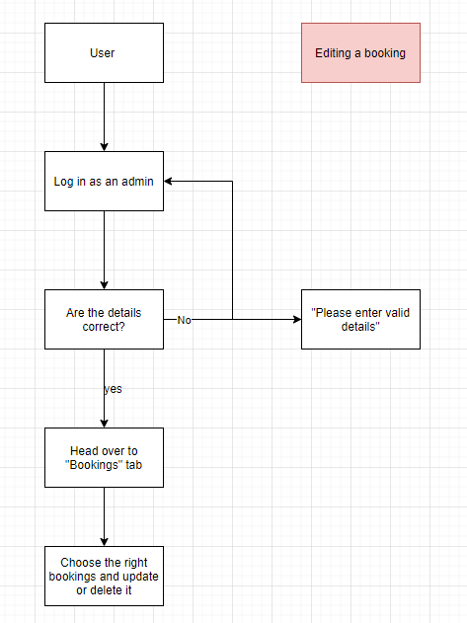

*(fig. 7)*

**Heuristic Evaluation Analysis**

The following usability criteria have been assessed in an attempt to evaluate the suitability of provisional system designs against established good design principles.

**Conformity Key**

1 = Conforms in all parts.

2 = Conforms in most parts.

3 = Conforms in some parts.

4 = Does not conform.

|  |  |  |  |
| --- | --- | --- | --- |
| **Usability Criteria (Heuristics)**  **Appropriate use of:** | **Level of Conformity**  **(1-4)** | **Evidence/Examples of application** | **Additional Comments/Issued Raised** |
| **Metaphors** | 2 | Website presents images that can be viewed and changed but only through code, allowing staff to change them using admin panel would greatly benefit the website interactions |  |
| **Consistency/**  **Perceived Stability** | 1 | The website works consistently and does not present users with any kind of errors throughout |  |
| **WYSIWYG** | 1 | The website is really straightforward and does not lead to secret pathways that you don’t expect. Every title gets you to the relevant content |  |
| **User Centred**  **Control** | 1 | The website follows a simple three-click-rule which is applied throughout the whole website so that is it user friendly to all audiences |  |
| **Feedback and Dialog** | 4 | As of now there is no way to leave feedback about website | Additional functionality for reviews can benefit the website greatly |
| **Forgiveness** | 1 | Overall the website is forgiving and always will give you a chance to back to homepage and start again |  |
| **Interface Text** | 2 | The text on the website is a basic font, that can be improved to fit with the theme of the website better and give users better visual experience |  |
| **Buttons** | 1 | The website gives you all the relevant buttons that lead you to the destined page |  |
| **Icons** | 1 | All the icons represent their relevant figure and are usable on the website |  |
| **Colour** | 1 | The design of the website looks good and flows together well | aged design |
| **Modelessness** | 1 | Overall the model of user interface is easy to follow and use. |  |

Main challenges

Fundamental challenges for the project will be set as a checklist. There will be a set of basic requirements that will be the core functionality, and additional functionality to be implemented if the customer wants to.

* Investigate pre-existing application systems
* Recovery of information for each staff member and client from database to implement personal statistics on performance
* Making the system easy to use and responsive so it can be used on any device
* Create a staff area where a “main” admin and add/delete/edit new staff
* Proper implementation of the database to the website for long term use

**Why they are important**

These functions will be the hardest functionality tests to achieve along the way building the website itself. They will be hard for the developer because it can be difficult to set a lot of values that will be sent from and to the website. This points out the lack of code quality and poor attention to detail. The developer will be working on those challenges by improving code quality and finding resources that will further help the developer improve the code and become a better programmer.

Legal issues & Social issues

With this project certain social and legal issues will be touched on. As the staff area will be implemented, passwords and personal information will be stored in the database. Guidelines of Data Protection Act. will be set. Social issues might include problems with customers when they create appointments and are late for the appointment. That can cause problems which will need to be discussed further with the client and dealt with ethically.

Information security will be strictly applied throughout the website to maintain the highest level of security and confidentiality.

Below are different ways the website will make sure it's fair use and is protected by the law.

1. **The Companies Act 2006**

The Act requires you disclose certain information about the identity of your company on your website.

* Company name
* Company registered number
* Place of registration, such as England and Wales
* Registered office address
* Your company name, postal address and company email address
* How to contact your business via non-electronic means
* Your VAT number, even if the website is not being used for ecommerce transactions
* The name of any trade bodies or professional associations that the business is part of, including membership or registration details.

1. **The right of users to grant consent for the use of their data.**

* Preferences on your web contact forms set to default to “no” or blank, and users have to actively opt-in
* Making it easy for users to withdraw their consent or opt-out
* Forms should collect a minimum of information, and only the data required for the task at hand
* Notifying users of cookies that are being used to track their behaviour
* And have in place a [data breach process](https://www.hallaminternet.com/data-breach-response-plan-checklist/) in case the worse happens.

1. **The company policies and procedures**

* A [privacy policy](https://www.hallaminternet.com/privacy-policy/) that details what personal information your business collects, and how you use that information
* A cookie disclosure explains how your business uses cookies on your website.
* A disclaimer stipulating how users can use the information on your website, and what liability (if any) your business accepts.

1. **Respecting the copyright**

* All the images that will be used are copyright free images.
* This website is detecting all the other websites that could be infringing the website copyright.
* That the website is protected against copyright.

### Progress

Current progress preceding the proposal includes:

* Talking with the client and staff about the project
* Creating a version of the requirements and main challenges for the project
* Investigating pre-existing business models and looking at them with the client
* Reading academic literature to gain a better understanding of the problem and its solution
* Setting up the server and filling draft database tables that will be used

### 

### 

### Further investigating

By having more discussions with the client and the employees the developer started creating the website from the back-end. This seemed like a good way to get the website off the ground and created database tables, routes and controllers. This will help the developer along the way to then build on it and improve the website in different ways. More literature about website development and software engineering helped the developer shape and theorise hope the finished product will look. In developers opinion that helps look at the broader picture rather than just thinking about the functionality of the website and making the client satisfied. It also makes you think about the further maintenance of the website and further improvements and making sure you leave good structured code for different programmers to maintain efficiently.

By now the website and reports are at interim stage. By this point the developer has achieved satisfactory levels based on the gantt chart. Further the start of building front-end and back-end of the website and continue filling the report and talking with the client about improvements along the way. Right now the developers goals can be spread out in bullet points for easier understanding:

* **Finish working on back-end improving quality of the code**

Learning the quality of the code from different sources and applying them to the website, organizing folders and files, naming them properly, indenting code, and writing “solid” code.

* **Start working on the front-end functions of the website**

Making sure with the client that all the functionality that was provided in the proposal will be met and the client is still happy with them.

* **Properly design the website**

For the design of the website couple points will have to be brought up. For example, the website needs to look good but also not have any latency issues with weaker computers not allowing users to use it efficiently. Trying out websites on the phone and looking if this could be additional features that can be done in the proposed time frame.

* **Finishing the website and documentation**

By this point all the functionality and design of the website will be done and will be tested using white-box and black-box testing. This will make sure the website is working properly and will be available for future improvements if needed.

## 

## 6. Test Strategy

**Overview of Test Strategy**

The testing strategy will be divided into multiple parts. It will be aimed at testing all the parts of the system, both front and back end.

**White testing box**

First set of tests will be full functionality testing of the front end of the website. Seeing if all the functionality is working properly under different conditions and different browsers.

|  |  |  |
| --- | --- | --- |
| **Functionality** | **Expected result** | **Actual result** |
| Navigating through website | Anyone should be able to navigate the website using the navigation bar | Works as intended |
| Registering an account | User should be able to register an account | Works as intended |
| Logging out of the account | User should be able to log out out of active account | Works as intended |
| Booking an appointment | Logged in user should be able to book an appointment | Works as intended |
| Not being able to book without being logged in | If user is not logged in, you should not be able to book an appointment | Works as intended |
| Logging in as an admin | You should be able to log in as an “admin” | Works as intended |
| Checking the bookings tab | When user is an admin they should be able to check and see all the bookings that salon had | Works as intended |
| Using CRUD as an admin on bookings | Admin should be able to use the functionality of create, read, update and delete bookings | Works as intended |
| Functionality of the “news” page | The functionality of front pages should work as intended | Works as intended |

**Black box testing**

Continuing the white box testing, the developer will do a series of black box testing on the website. Black-box testing is a method of software testing that examines the functionality of an application without peering into its internal structures or workings. Testing will be aimed at fragile parts of the functionality

|  |  |  |
| --- | --- | --- |
| **Functionality** | **Expected result** | **Actual result** |
| bypassing URL links | User should not have the ability to write a URL link to the bar and access that page | Works as intended |
| Works on different devices | Website should be able to work on different devices | Works as intended |
| Works on different browsers | Website should be able to work on different browsers | Works as intended |
| Password should be hashed in the database | All passwords must be hashed inside the database | Works as intended |

**Other testing methods**

To test the ease of use and the flow of interactive functionality on the website the developer has asked different people to use the website and book a couple of appointments. This gave the developer a third person view on how the website is used by people who would like to use the website for its functionality.

The tests went well and no significant changes were needed.

System testing

From beginning to end testing will be a vital part of the project. As the developer will be creating the application, the developer will be constantly testing the newly created functions and programs. When software is completed, white-box and black-box will also take place to ensure the integrity and security of the application. Staff trials will also be a part of testing to get a better understanding of the application from another perspective; is the design intuitive, are the core functions working properly and so on. Overall all the testing is to ensure that the project meets all the client specified requirements and is satisfied with it.

Possible further improvement for the website

For further improvement of the website, the developer would consider implementing more functionality to improve life quality. For example, adding a choice of rooms if business had expanded. Another implementation the developer would add is a payment system on the website. Right now, as the prices are yet to be decided, the client has decided to have people book the appointment online, but come to the salon to pay for it. This system is not the most reliable as it is built on customer trust that they will come, but is also the best choice for the website as of now in the early stages of launch.

**5.2.2 System Pilot Trials**

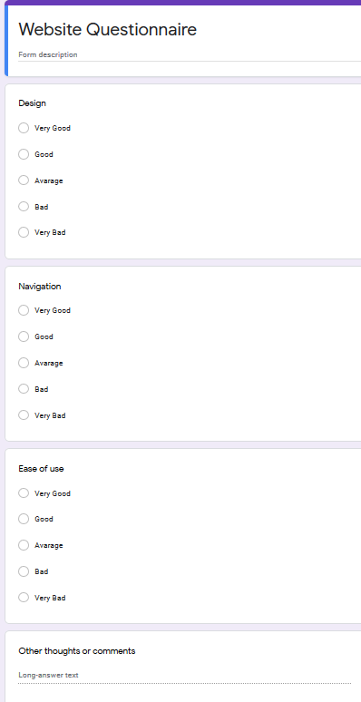

**5.2.3 System Trials Results**

* **Design**

Overall the design answers gave answer of: Average

* **Navigation**

Overall the navigation score was: Good

* **Ease of use**

Overall the ease of use answers gave answer of: Very Good

* **Comments**

“The website flows really well together and design is complimented on each page, but it looks aged and could be improved.”

## Evaluation

Overall the developer was satisfied with the website but also has a list of future improvements:

**Design**

Right now the design of the website looks aged. This is not a good first impression for new customers and could turn away some people. For future development of the website the developer suggested an improvement of the design.

**Rooms**

The developer has also mentioned a development of rooms to be added as an option for customers to choose between similar times if one room has it booked and another one does not. This was discussed with the client but would require future development as only a demo placeholder is at that point right now.

**Repeated code**

As of now there is quite a bit of repeated code the developer has mentioned, using a framework like laravel can help with those problems and could be a good idea transferring to it in the future.

**Overall satisfaction**

Due to loss of contact with the client the developer has identified the website to be overall satisfying although needing improvement in the future development of design and quality of life for the user. The simplistic design allows for easy use and flow of the website. Even though the website only presents only the most crucial functionality, it still feels professional as it does not show users any kind of irrelevant or unwanted information and is straight to the point.

## 5.3 final system interface displays

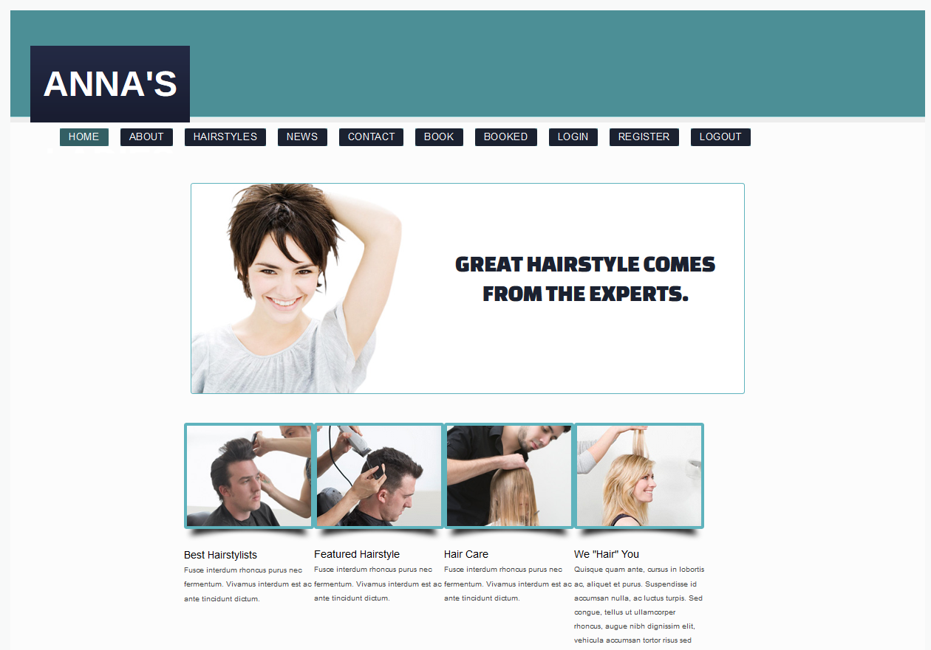

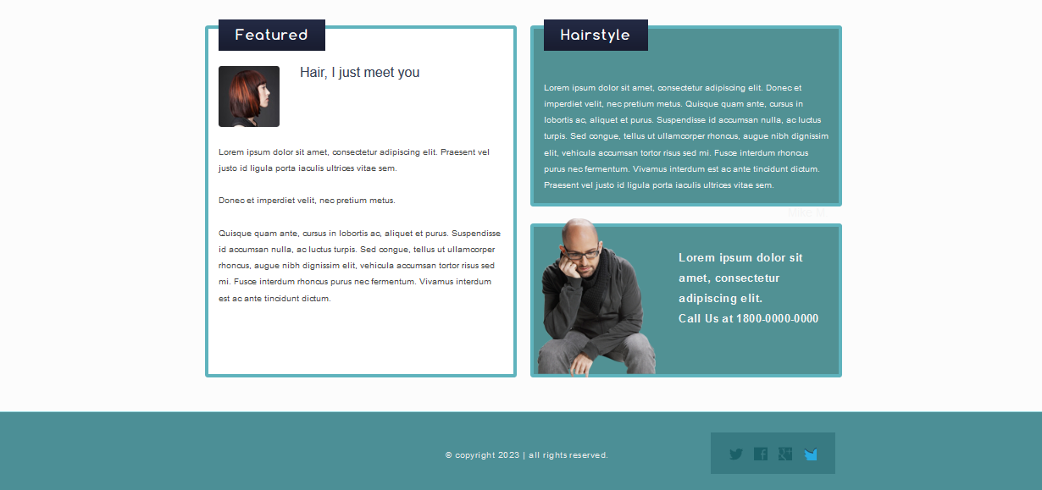

*(fig. 8 “Home page”)*

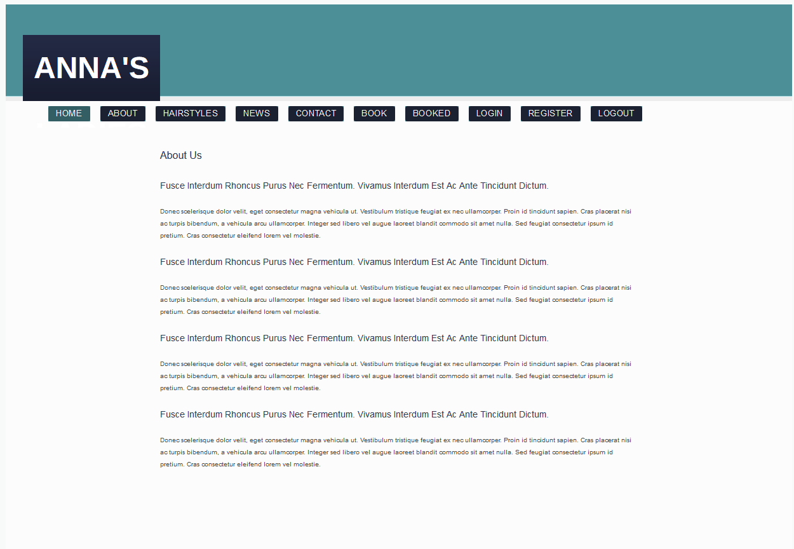

*(fig. 9 “About us page”)*

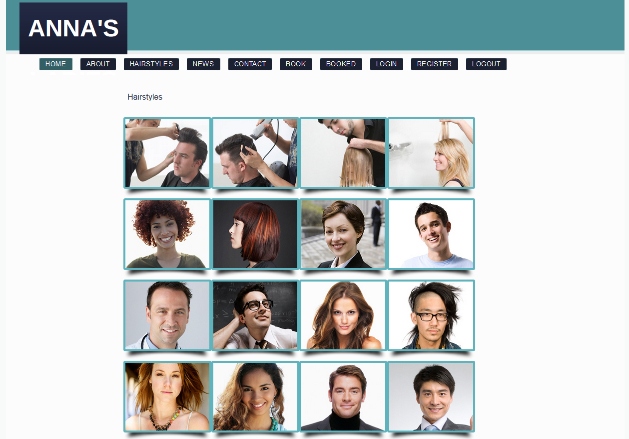

*(fig. 10 “Hairstyles page”)*

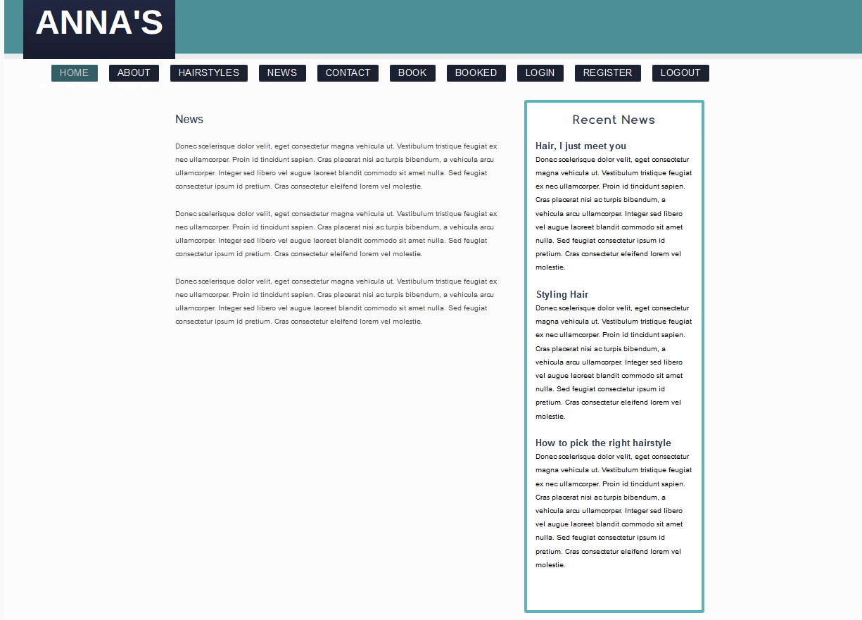

*(fig. 11 “News page”)*

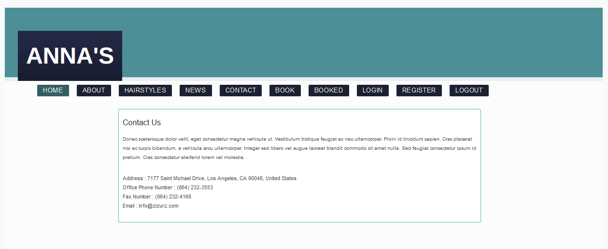

*(fig. 12“Contact us page”)*

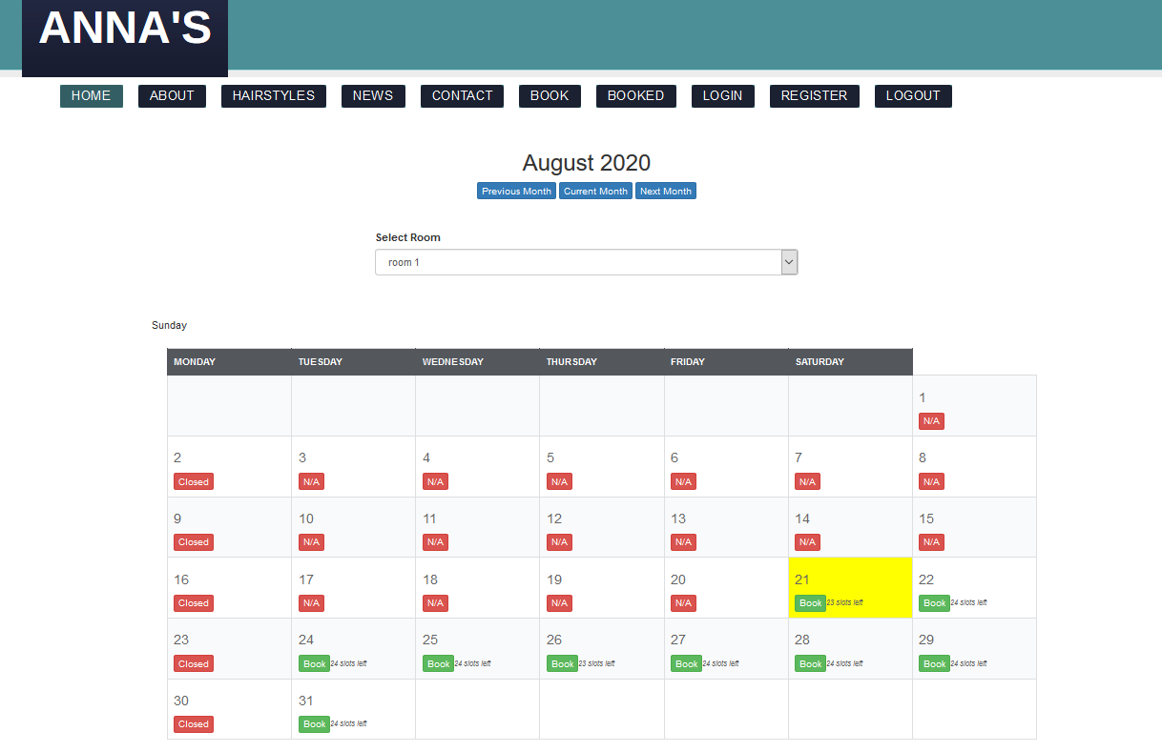

*(fig. 13 “Book page”)*

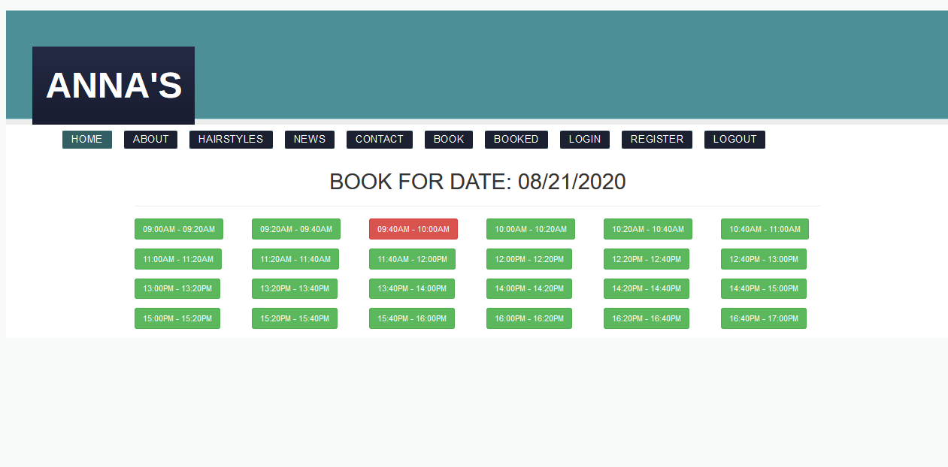

*(fig. 14 “Book page”)*

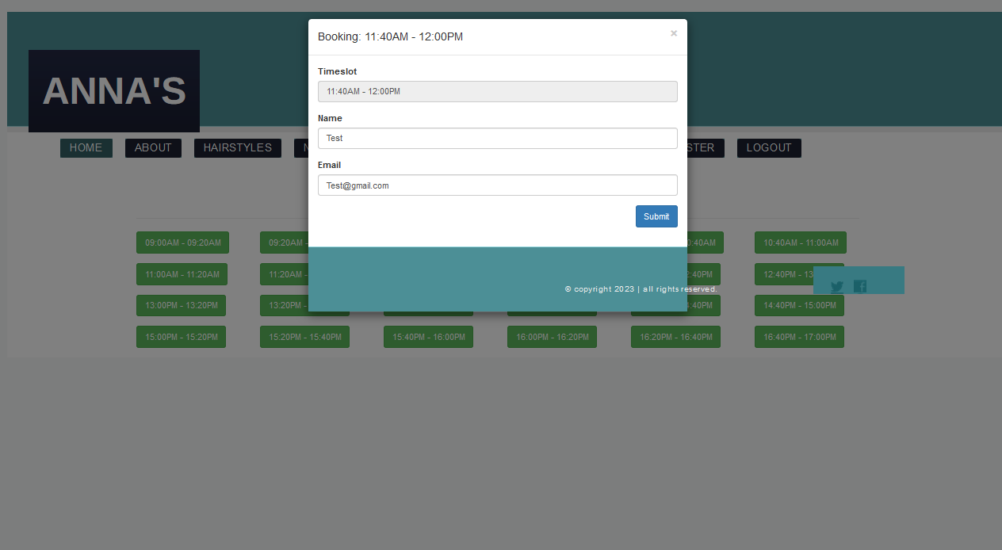

*(fig. 15 “Booking interface”)*

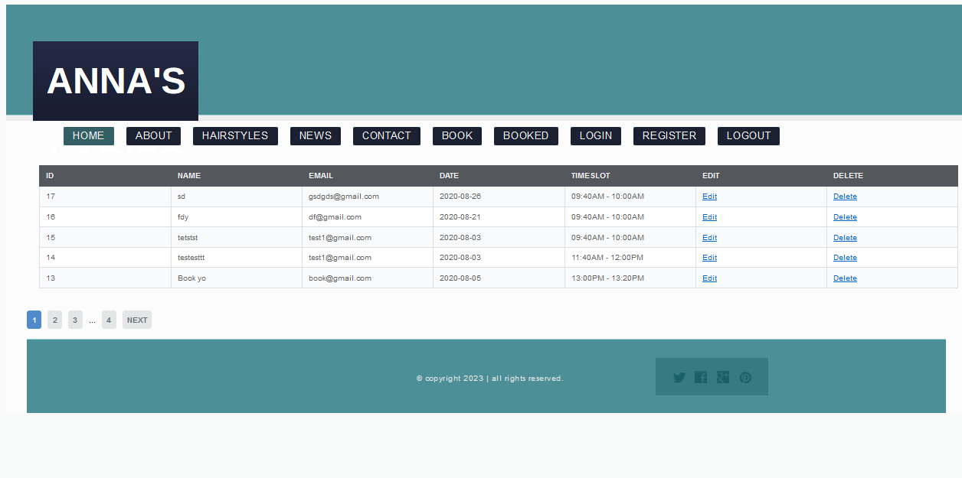

*(fig. 16 “Bookings page”)*

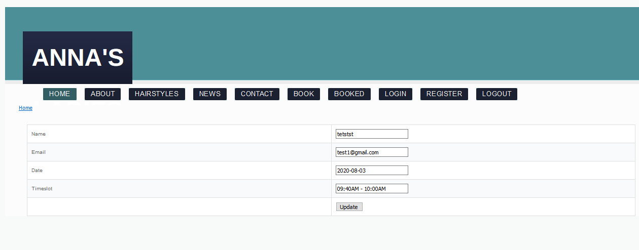

*(fig. 17 “Bookings CRUD page”)*

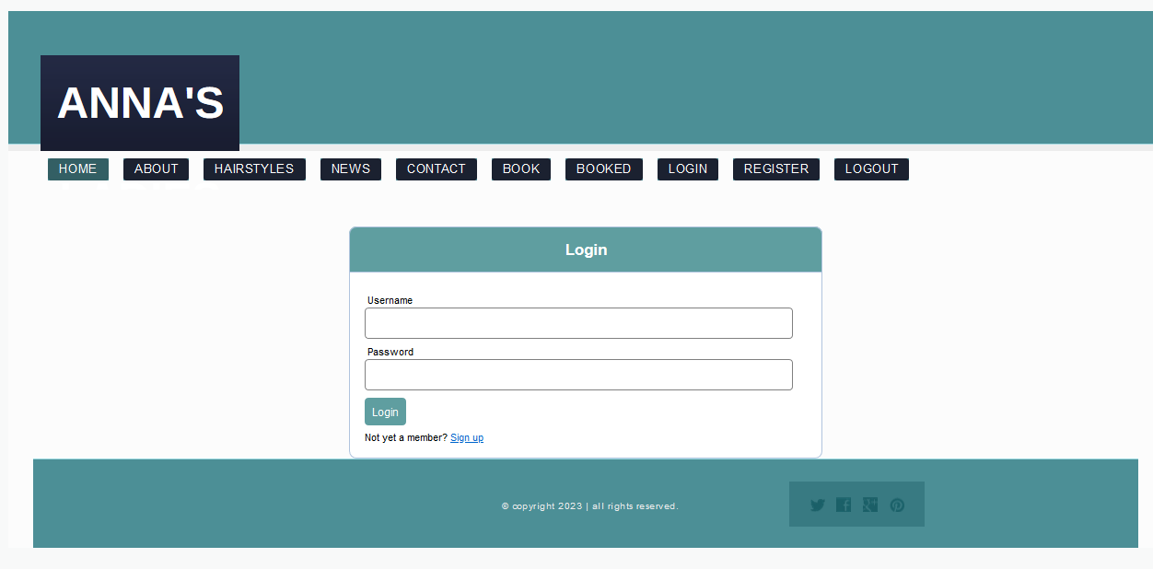

*(fig. 18 “Login page”)*

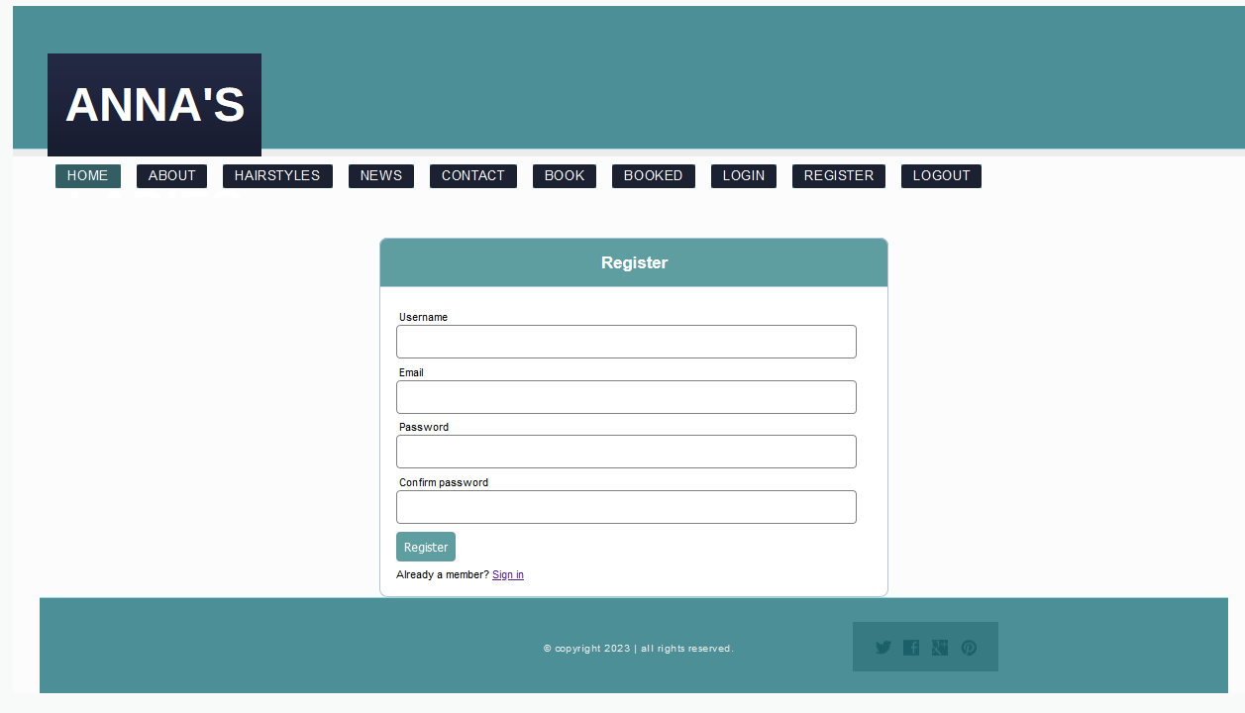

*(fig. 19 “Register page”)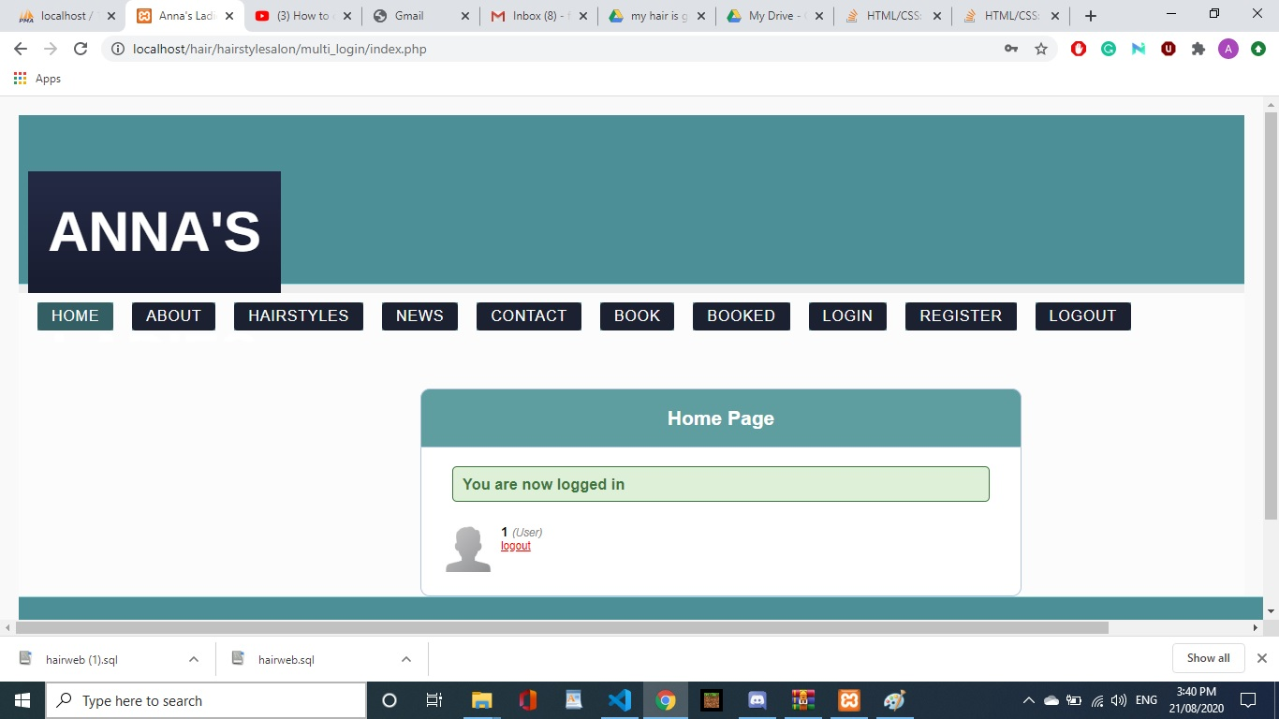*

*(fig. 20 “User logged in page”)*

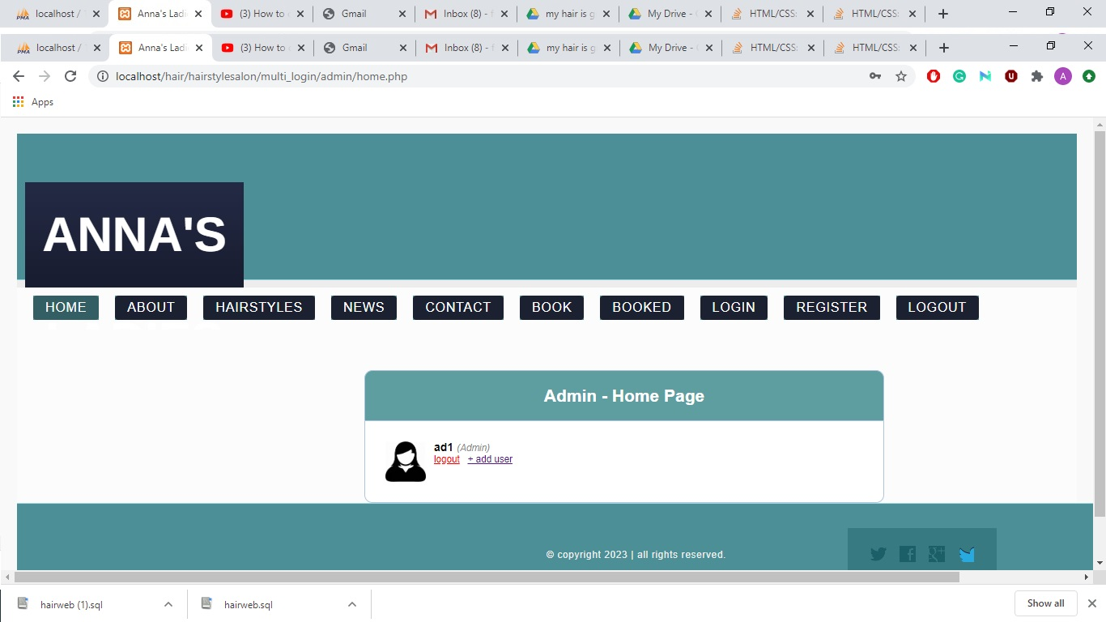

*(fig. 21 “Admin logged in page”)*

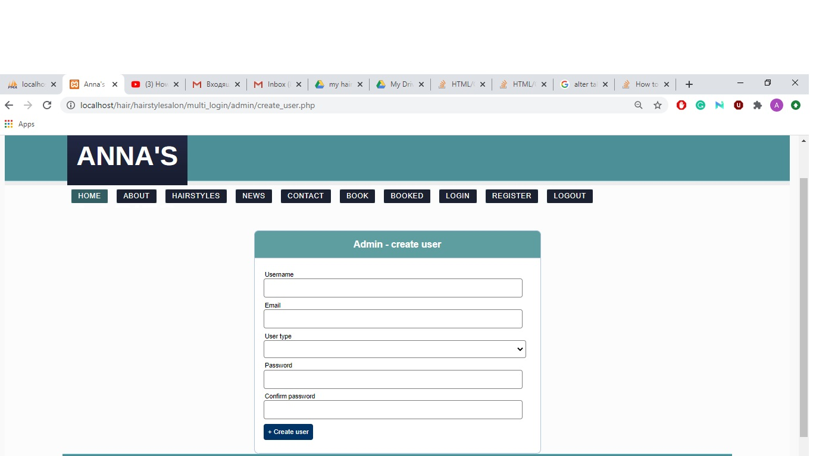

*(fig. 22 “Admin create a user page”)*

Presentation slides



*(fig. 23 “Admin create a user page”)*

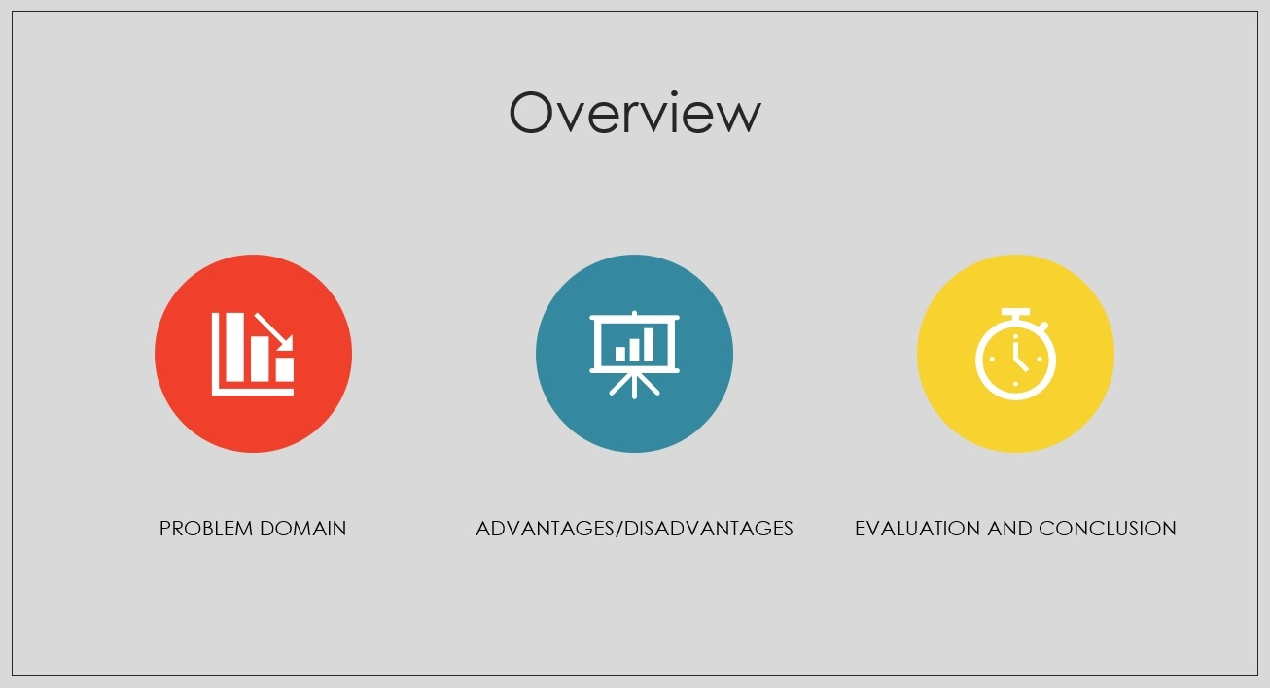

*(fig. 24 “Admin create a user page”)*



*(fig. 25 “Admin create a user page”)*

References

**Web-Based Medical Appointment Systems: A Systematic Review.** Zhao P1, Yoo I1,2, Lavoie J3, Lavoie BJ4, Simoes E1,2. J Med Internet Res. 2017 Apr 26;19(4):e134. doi: 10.2196/jmir.6747. <https://www.ncbi.nlm.nih.gov/pubmed/28446422>

**Business and Information Systems engineering** Christof Weinhardt, Martin Bichler 27/09/2017 https://www.springer.com/journal/12599

Nasir, M., Hamid, S. and Hassan, H. (2009). WebML and .NET Architecture for Developing Students Appointment Management System. Journal of Applied Sciences, 9(8), pp.1432-1440.

**Online Doctor Appointment Booking System PHP and Mysql -** https://www.youtube.com/watch?v=KqpKRv9m-PU

**Doctor Appointment Booking System in PHP**

https://www.youtube.com/watch?v=mOsG6ehkMQc

**best clinic appointments management system in php part 1**

https://www.youtube.com/watch?v=CnfHWvigt94

**How To Build a Simple Appointment Booking App (Mongo, Express, Angular, Material)**

https://www.youtube.com/watch?v=DAlvbZzrppQ

Appendix – Project Gantt Chart

